Top 10 World’s Richest Bands
WRITTEN BY ASH MEERAIYA

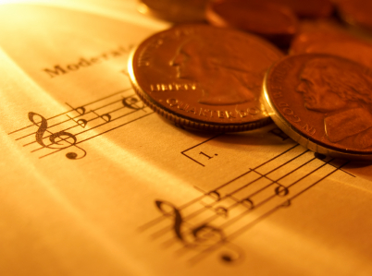
I’m sure I don’t need to tell you that the music industry is a multibillion dollar business. It’s not just one of the largest economic proliferators within the media industry but of the world. It brings in big bucks, a fact some of the richest bands in the world are all too familiar with.
Even if you haven’t heard of all of the bands mentioned in this list, the artistic alchemists that have turned the intangible lyric into cold hard cash, you would have heard their music; playing in the background of your favourite film, at your local café and even remixed on the last dancefloor you found yourself on.
While some of the bands on this list have long since faded into the history books the most telling thing about the sheer power and influence of the bands here is that they still, despite the noticeable handicap of not being around anymore, remain at the top. Whether through syndication rights, royalties or world tours the wealth for these artists rolls on, as unstoppable as their music ever was.

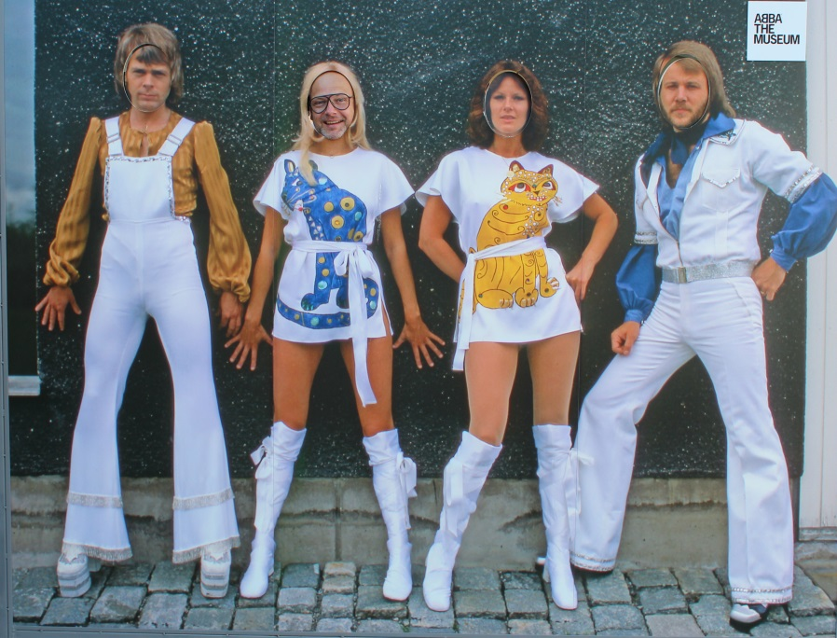
10. ABBA – Certified unit sales: 58 million

At #10 on the world’s richest bands list is the Swedish band ABBA – an acronym of the first letters of each of the band members’ names: Agnetha Fältskog, Björn Ulvaeus, Benny Andersson, and Anni-Frid Lyngstad – a name that alone represented just how integral each person was to the band.
If the fact that this band being the only Swedish band on this list doesn’t speak volumes about how unique they were then the fact that they took only 10 years to match the heights of similarly rich bands, says it all. With their 1976 hit ‘Money. Money, Money’ making it to third place on the UK charts it comes as no surprise that that is exactly what they made plenty of.
1972 was the year of their first album and despite their relatively short climb to the world stage they brought us hits such as Fernando and Dancing Queen. Hits that saw this pop/disco band usher in the disco era.

9. QUEEN - Certified unit sales: 61 million
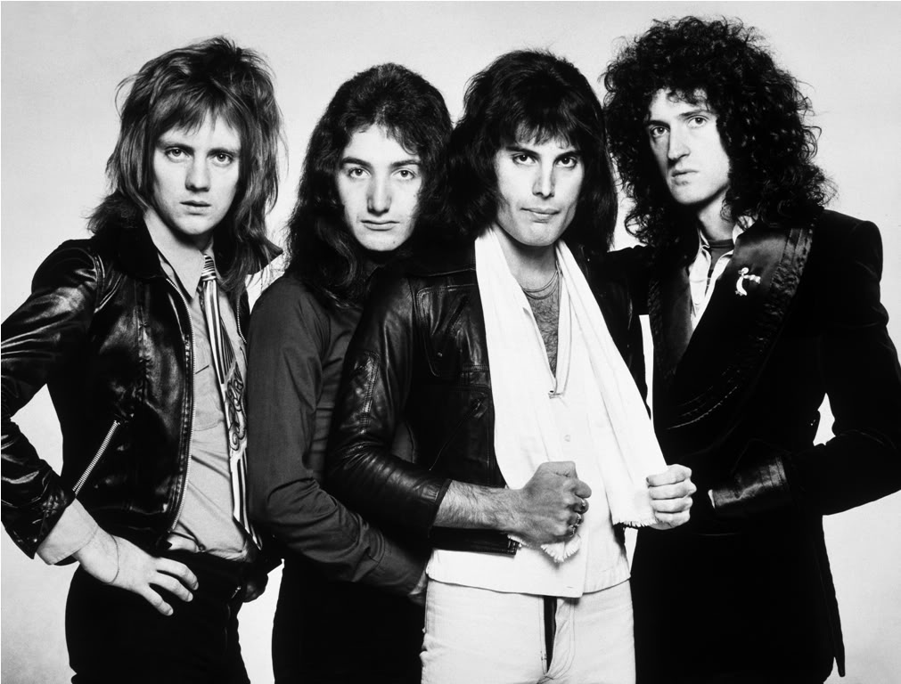
Even though this band appears on the list they were concerned less about making money than making LEGENDARY ROCK MUSIC. They made songs worthy of the title power ballad. Since their first album in 1973 the four have been hitting the mark and the top of the charts for that matter with every hit they pelt out.
Freddie Mercury, the lead singer of the unstoppable force that is Queen has since died, and while he remains irreplaceable Queen lives on. They’re still making money from tours and special concerts due to their invested popularity that still earns them sell-out shows.
The men flew in the face of convention - a prerequisite for Rock if ever there was one. Confronting…and…couldn’t care less.
http://youtu.be/ReIL4l4OTPI
The Best of Queen by DJ Fuzi

8. THE ROLLING STONES – Certified unit sales: 66 million
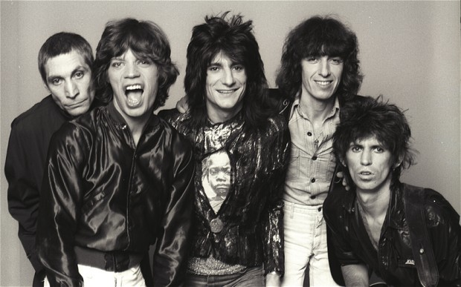
A U.K. band of the 1960’s that’s active even still to this day. Alongside lead vocalist Mick Jagger they’ve enjoyed careers that have earned them over $200 million dollars in concerts alone excluding the millions of dollars in branded merchandise that wouldn’t be complete without the old rolling tongue and lips symbol that is the logo of the bands iconic call to fame (a joke at Jagger’s expense, I still don’t know).

7. Aerosmith – Certified unit sales 66.5 million
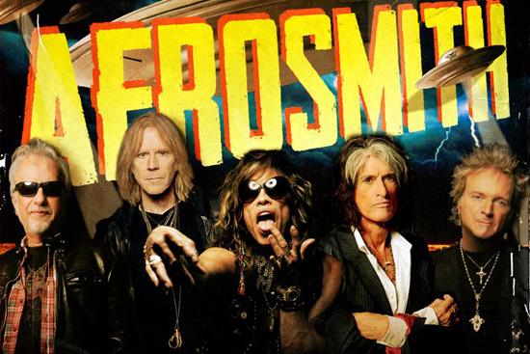
The only thing that matched the heights of lead singer Steven Tyler’s voice-box is this bands accumulated wealth.
While their illustrious career has been marred by a long list of scandals since their debut in 1970 they’ve made many hits over the years especially during the 1980’s where they were topping the charts. After the back and forth between the members and even talk of Aerosmith quitting the band they -how should I put this- struck a chord with fans by the explosive response to their ‘Toys in the Attic’ album. This included their hit Big Ten Inch, the double entendre here referring to older records being 10-inch, 78 RPM vinyls and then the well…obvious. They probably should’ve just called it Big Ten (fl)Inch with all the hype it caused. With an upcoming U.S. tour expected July 2015 they can count on the fact that their money will keep rolling in.

6. AC/DC – Certified unit sales: 71 Million
1
At a combined net worth of $200 million dollars, AC/DC is the only Australian band to make it to this list. They are another band that was formed in that 1973 sweet spot and while the band itself has been through a fair few drummers and bassists the bands core members remain, the two brothers who formed it, Guitarists Angus and Malcolm Young.
AC/DC, and there’s nothing to say that they’re changing anytime soon, have always been about producing electrifying Heavy Rock hits that would blast out of stadium speakers. It’s no surprise then that the band’s first album was called ‘High Voltage’ carrying through the theme made so shockingly clear in the band name.
The band made most of its wealth in that decade that followed its formation with their No. 1 hit ‘Back in Black’. This album, on par with Pink Floyd’s ‘The Dark Side of the Moon’, were tied at the second highest selling albums of all time. A true testament to the memory of long-time friend and lead singer Bon Scott who died at 33 and who this song was an ode to.

5. Pink Floyd – Certified unit sales: 74.5 million
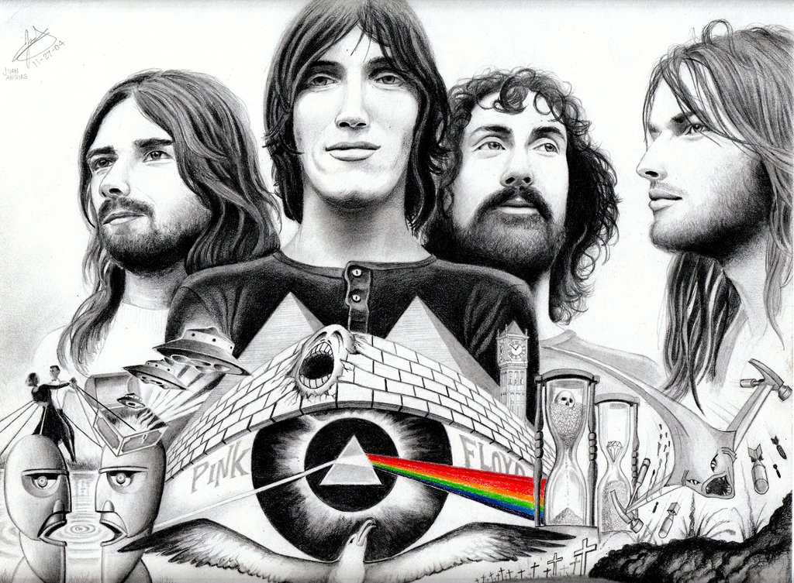
Just another one of the great U.K. bands featured on this list, this one active for 30 years. In that time they sold over 74.5 million albums (certified), the unofficial total likely closer to 100 million albums and this amounting to $250 million dollars’ worth of record sales and concerts.
Pink Floyd’s hallucinatory psychogenic music was a corrosive inhalation of rock bred with sonic experimentation that the fans just couldn’t get enough of. Even today fans are still getting high on Pink Floyd’s psychedelic batch of music.
http://vimeo.com/57338243
‘The Dark Side Of The Moon’ – Money

4. The Eagles – Certified unit sales: $100 Million
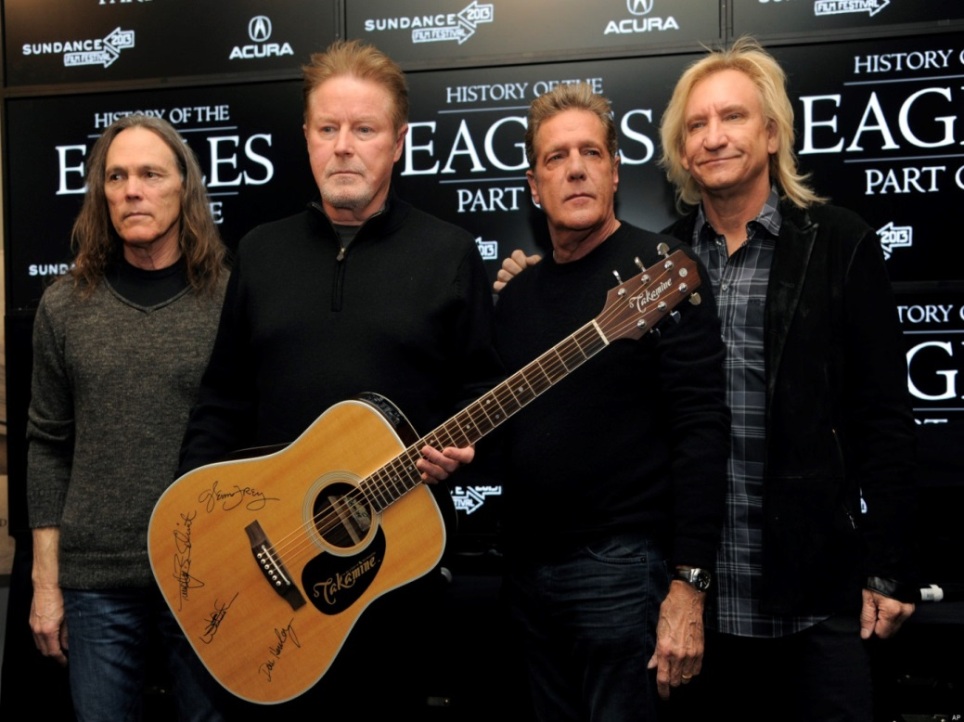
After taking a break for 14 years during their career it’s a wonder that this band made it to fourth on this list but then if you’ve heard their music it’s not.
Debuting in 1971 they were only active for 9 years but during that time they made ‘Desperado’ and ‘Hotel California’ two of their bestselling singles. After that they didn’t play together again until 1994 when they got back together and have been touring ever since including recent sell-out shows in Sydney, Australia.

3. Led Zeppelin – Certified unit sales: 111.5 Million
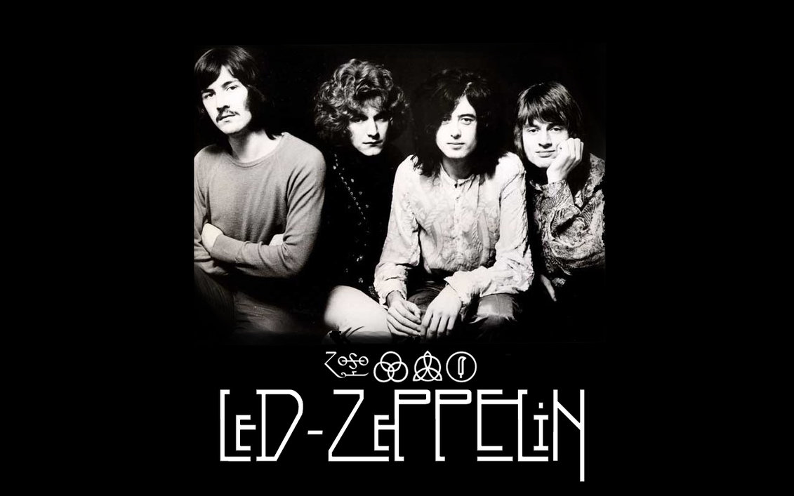
This hard rock and heavy metal crossover band, active for only 12 years since their formation in 1968, has earned a whopping $300 million dollars to date.
Their immutable style, yet in itself unchanged, changed an era; some credit them for being the co-creators of the heavy metal genre. Whatever the case may be ‘Led Zeppelin IV’ was easily their most widely known album and screams why they were so critical to the genre.
http://vimeo.com/61616524
‘Led Zeppelin IV’ (1971)

2. U2 – Certified unit sales: 150 Million
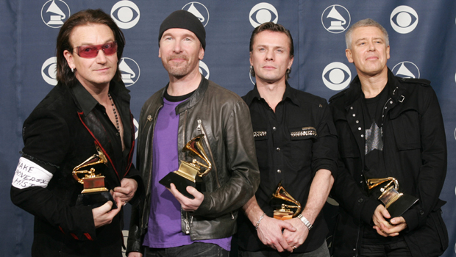
The silver medal goes to the Irish band, popularised by Paul David Hewson or “Bono” as he is more widely recognised as. U2’s career has only ever been coloured by success and that’s not at all a crack at Bono’s ever-present shades which in 2014 he reportedly said, he wears more for his glaucoma condition than any fashion statement The Guardian 2014:Bono on glaucoma.
. That’s not to say though he’s not himself a fashion icon, I mean he was of course chosen by Louis Vuitton to model their billion dollar brand name in 2010.
The band between them share an astronomical $838 million in net worth to their name and why shouldn’t they when the money they’ve generated for charity organisations worldwide far exceeds even that. To date they’ve performed for over 22 charities from DATA (debt AIDS trade Africa) a fundraiser Bono co-founds, to Nelson Mandela’s – Legacy of Hope Foundation. Worthy enough to make the list wouldn’t you say?

1. The Beatles – Certified unit sales: 250 Million
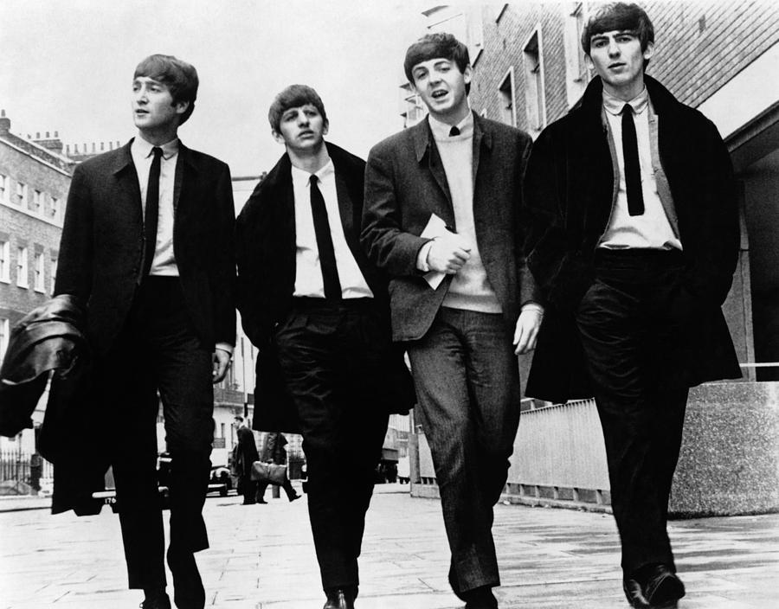
The #1, the only (and anyone who appreciates music for what it is could’ve guessed) - the Beatles. John Lennon, Paul McCartney, George Harrison & Ringo Starr. The “Fab Four” as they were known in their earlier years caused more faintings at concerts than any other band of the time. The affliction was so rampant that they had to name it – Beatlemania – the Beatles crooned and the women swooned.
Although this list notes that they sold 250 million albums, when counting all sales the number reaches the 600 MILLION mark. But apart from just good music why were they so popular? They weren’t just credited for making music in an age of changing times they themselves changed it by turning the genre on its head.
The year was 1960 and experimentation was the order of the day; drugs, activism and of course music. The Beatles were known for experimentation within their music. While using rock ‘n’ roll as their anchor they found inspiration from pop ballads, heavy rock, psychedelic and even roamed as far as Indian acoustics. While some bands that may not have made it to this list (but are still successful in their own right) might not realise it, in some way or another they will have been influenced by the world’s richest and greatest band, the Beatles.

For those diehard fans or even the person who just wants to know more about their favourite artist check out these titles from Fashion Industry Broadcast
Their Masters of Music series follows the life stories of history’s greatest artists – The ups, the downs and all the hits in between.
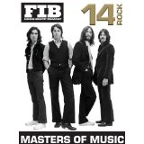 (Includes among others: the Beatles, Aerosmith)

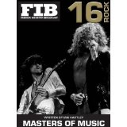 (Led Zeppelin, Pink Floyd, Queen)

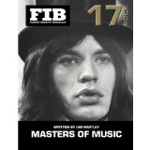(The Rolling Stones, U2)

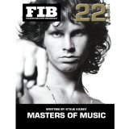(ABBA)
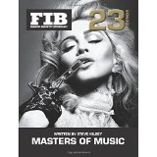(The Eagles)

